Supplements to
Poker Plays You Can Use
Volume 2

Written by
Doug Hull

Card Images
 |  |  | 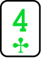 |  |  |  |  |  |  |  |  | 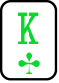
 |  |  | 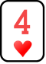
 |  |  | 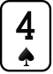 |  |  |  |  | 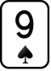 |  |  |  | 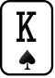
 |  |  | 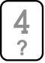 |  |  |  |  | 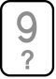

Hand Action Charts
Use these to document your hands.
$1-3  Mirage | Image: | Action: | Hand: | Starting Stack:
CO | Hero | Straddle $6 |  | $250
Small Blind | Villain | Call |  | Covers
MP2 | Unknown | Call |  | $300

 | Pot: $81 | Range: | Starting  Stack:
Villain  (Small Blind) | Check/Call |  | Covers
Unknown  (MP2) | $45/Fold |  | $280
Hero  (Cut-off) | $90 |  | $230

Player Profiles
Start with these and modify them as you see fit for personal use.

NONIE
Weak, passive
Losing recreational player
Las Vegas Local
Buys in $100 at a time
Loves talking about her grandson
Limp | Raise |  | 3-bet
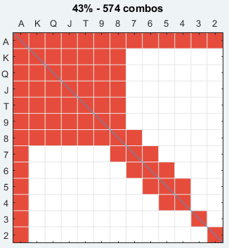 | 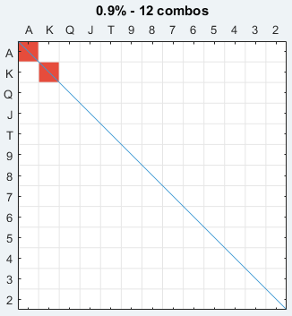 |  | 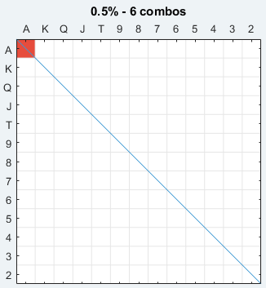
Pre-Flop limping: Nonie is quite sticky pre-Flop. She will limp/call a pre-Flop raise with her entire limping range. You never know what she is going to call with pre-Flop. Has no idea of the implied odds of her calls. She might set mine with 66 for 25% of her stack. She might just limp/call with KK. She might limp/call with 65s. She is a frequent open limper and over-limper.
Pre-Flop aggression: She very rarely raises pre-Flop, and it is always a tiny raise like $5, regardless of the number of limpers. This pretty much guarantees she will go multi-way post Flop. She seems to always have premium pairs when raising. Nonie basically only -bets Aces, but she could just limp call with them also.
Post-Flop
Nonie will sometimes just donk out with top pair regardless of pre-Flop action. She will never bet with a draw. She will not float intelligently, though sometimes if she thinks a player bets too often, she will give a call with random overcards or a middling pocket pair. There is not much more to her plan than calling the Flop.
It is hard to pressure her since she almost always has a short stack. She will play fit or fold on the Flop. She will bet Flop with top pair plus, but bets too small and rarely will fire for value on the Turn and River because “the Pot is big enough for me.” The only way her entire stack goes in is calling down more aggressive players. She will frequently be outkicked in big pots. She constantly leaves value on the table. She once checked the nuts, in position on the River “Because he would not call me anyways.”

BRIAN
Decent, ABC player
Winning professional player
Buys in $300 at a time, keeps rebuys in pocket
Watches movies and poker videos at table.
Plays Open Face Chinese Poker at table with other pro players.
Anti-social to most players.
Limp | Raise |  | 3-bet
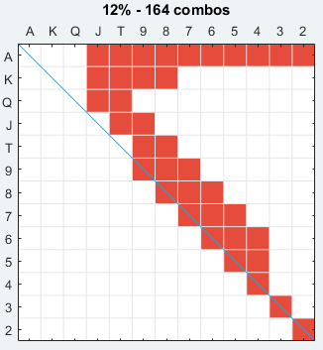 | 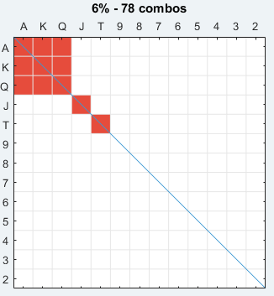 |  | 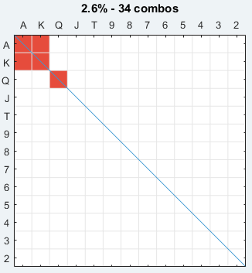
Pre-Flop limping: Brian has some discretion and does not just come in with junk. He is fine with being an open limper. In later positions the stronger limping hands become raises. When aggressive players are at the table, he is willing to limp-re-raise with strong hands.
Pre-Flop aggression: In later position, he will raise more hands. His raises get bigger based on the number of limpers, raising between $8 and $15.
Post-Flop
Brian is more creative than a fit or fold player. He will bet his better Flush draws and open-enders. He has been known to check-jam Flush draws on the Flop. He needs to be attacked frequently to do this, preferring to “get there” first by default.
He will continuation bet and barrel indiscriminately with two naked overcards. He thinks his tight image affords him that luxury, in and out of position.
He is a classic set miner, he knows how much he can call to profitably set mine. Once he is stuck he abandons his rules and calls too shallow.
When he has green chips in his stack or scattered around the table, it
means he likely had to rebuy. When he is stuck a couple of buy-ins, he will decide to ride out the final stack without topping off. He is less good with the shallow stack, not adjusting to the stack depth. He will often blow through this last stack with desperate gambles.

(Creative Commons from Chris W on Flickr) |  | CHEN  Crazy loose, superstitious  Losing fun player  Wealthy  Buys in $300, often waiting for bigger game  Straddles every chance  Talkative and social.  Tips very well.
Limp | Raise |  | 3-bet
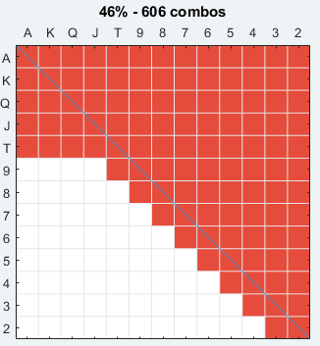
Pre-Flop limping: Will call most raises indiscriminately, especially with suited hands. Can get sticky with pocket pairs and limp over-jam medium pairs when he feels someone is messing with him.
Pre-Flop aggression: He will three-bet big with his premium hands. He is fine with blowing everyone out of the pot with a big raise since he does not want his Aces cracked. He will raise as wide as he will limp.
When losing, and short stacked, he is willing to open up his 3-betting massively if he can put on a big squeeze play all-in pre-Flop with junk.
Post-Flop
Chen never met a Flush draw he did not like. Anything approaching a reasonable shove on the Flop with a Flush draw is good for him. He can check-raise jam, he can donk lead jam, he can 3-bet jam.
There is some balance here because he will just donk out with odd strong hands that he makes like weird Two Pair, and sets. He has no problem with over-bets, donk bets, and check-raises.
His continuation bets tend to mean something, not just random overcards when he misses, but gushots, Flush draws, open-enders, underpairs if he leads. If top pair checks through, he overvalues underpairs, massively.
Because of his weak and wide limping range, it is very difficult to hand read him on combos. Bet sizing tells and patterns are more reliable.

TOM
ABC TAG
Break-even to slightly winning player
Serious recreational player
Is anxious to talk strategy.
Clearly well read in poker.
$300 topped off as needed.
Limp | Raise |  | 3-bet
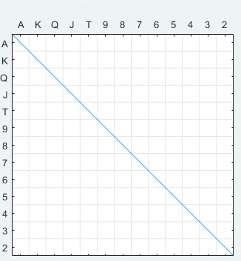 | 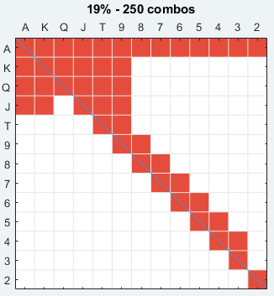 |  | 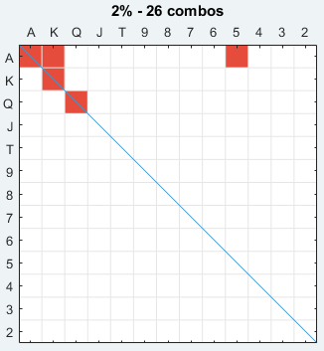
Pre-Flop limping: Tom really embraces the “Raise or fold” school of poker pre-Flop. It is rare for him to limp. If he does limp, it is in massively multi-way pots where there is no hope to take it pre.
Pre-Flop aggression: He has a strict schedule of $10+$2 for every limper when he raises. He will even raise Deuces over a limper for $12.
Post-Flop
His continuation bets are reasonable, though he biases towards c-betting overcards as bluffs and does not look for backdoor equity. He is pretty honest on the Turn, giving up unless he has something. If he started with a draw, only the most nutted draws with good equity get double-barreled: two overs and a nut Flush draw for instance.
A way to beat Tom is 3-bet him pre-Flop and collect on his many folds. He will make good stack depth decisions about continuing out of position. When he does play OOP to a three-bet, he will have a huge fold percentage on the Flop because he is usually looking for a set.

(Creative Commons from  Bold Content on Flickr) |  | ROHIT  Weak, unstudied player  Successful engineer  California visitor  Buys in $200, does not rebuy until busted
Limp | Raise |  | 3-bet
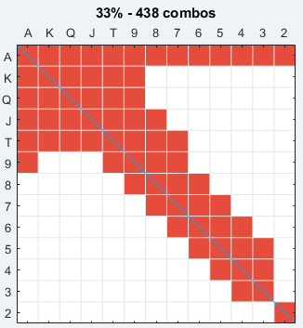
Pre-Flop limping: He is willing to limp in very wide. He makes some very unfortunate calls OOP when raised with lots of this junk.
Pre-Flop aggression: He is willing to raise with a fairly reasonable range. Has no understanding of how stack sizes should affect pre-Flop ranges.

Post-Flop
He massively overvalues one pair hands. His hand reading is abysmal. If a Flop checks through, he will go with middle pair like it is a set. He makes River bets with hands that will only be called by better. If he is a pre-Flop raiser and decides he is going to bluff at it, he will just three-barrel small but increasing amounts each street.
He will lead out with draws, even as a donk bet. He exhibits all the classic bet sizing tells.

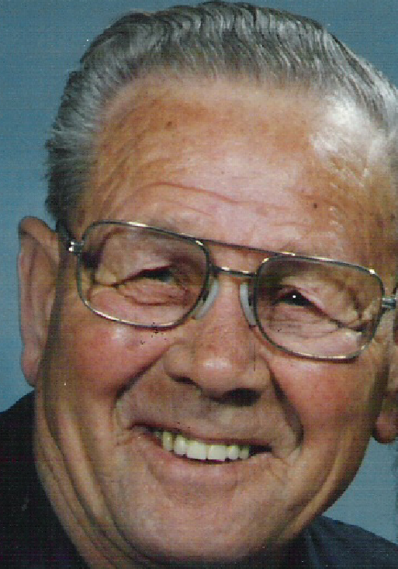 |  | ELLERY  Old Man Coffee  Buys in for $200, rebuys at $100  Comes to drink coffee and Flop sets  Every dealer knows him by name.  Retired businessman.
Limp | Raise |  | 3-bet
Pre-Flop limping: He loves it. He might raise pre-Flop with these premiums, but he might just limp with them looking for a limp re-raise. He might just flat and wait for a safe Flop with AA. Will fold frequently to pre-Flop aggression.
Pre-Flop aggression: Rare, but it is always a strong hand. Might make huge raises with premiums because he “does not want to see an Ace on that Flop.” Is capable of the min-three-bet with AA if not multi-way yet.
Post-Flop
Will check-raise with sets and good Two Pair. He will then hammer the Turn with these. He will call with draws, but not bet with them. He constantly leaves value on the table, but will call down with big pairs when good hand readers know that his Aces are not good.

BUD
Overconfident bad regular
Buys in for $200, rebuys at $100
Buys in with $20 bills
Has played forever, never studied the game

Limp | Raise |  | 3-bet
 | 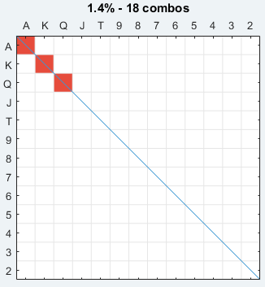
Pre-Flop limping: This is pretty standard for him. He will tend to call most pre-Flop raises without much thought.
Pre-Flop aggression: Very rarely. Will make big raises like $30 over two limpers. Would rather win what is in the pot than risk seeing an Ace on the Flop against his Kings or getting Aces cracked.
Post-Flop
Will donk out small on the Flop with weak top pairs to “see where he is at” Also will make the “same bet” on Turn and River. We can often float him, wait for a scary card to come and bomb the pot when it does. If we hit equity, we will have to raise smaller to lure him in. He does not notice our highly exploitable raising strategy.
If top pair checks through, he will gladly call down two streets with middle pair. Can easily call down three streets with hopeless kicker problems.
If he ever raises a reasonable amount post Flop or check-raises, we need to seriously have a good hand to continue.

JULIE
Weak Tight ABC
Buys in for $150, rebuys at $50
Learned a tight strategy
Is a poker dealer

Limp | Raise |  | 3-bet
Pre-Flop limping: She is completely capable of limping big premiums because she wants to see a cheap Flop. She does not use limping to see more Flops with a wider range. She does have starting hand standards, but is just not aggressive
Pre-Flop aggression: Very rarely. She uses the “3x the raise” when three betting regardless of callers in between. If she is raising limpers, it will always be $10, no matter how many there are.
Post-Flop
Hands that we think are worth three streets of value, she will passively call down and then bet for a small amount on the River. If she is betting at a pot, she has whatever the obvious big hand is. Any bet over $50 is a nutted hand. Will call down big bets but not make them. There is no semi-bluffing and rarely will she value-own herself by betting a hand that is beaten when called.

TYLER
Creative LAG
Overskilled for the game
She plays like you want to play
Always topped off to table max of $300
Massive winner
Giggles when felted by a ridiculous beat.
Limp | Raise |  | 3-bet
 | 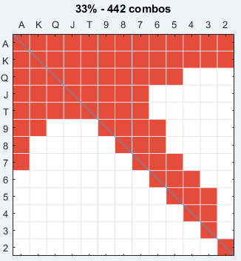 |  | 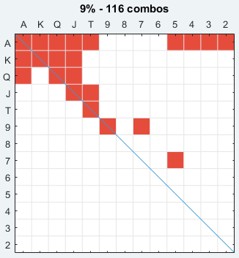
Pre-Flop limping: Never open limps. Can call behind with any of her raising hands if conditions are favourable. She much prefers raising though.
Pre-Flop aggression: Eats limpers for breakfast. Is by far the most aggressive player at the table. Willing to make squeezes, three-bet lite and four-bet lite against the right players.
Post-Flop
She knows all the plays in this book, and plenty more.
There are two ways to beat her: Slowplay monster hands and call her down. This is a difficult strategy because it is hard to make monster hands. She will value own herself (as she should) against these disguised hands.
The second strategy is to three-bet her pre-Flop. She opens too often in these games because normally no one will put up a fight. A few three-bets will shut her down, but it is rare for someone to do that at a high enough frequency to matter.

Portrait by Candy at the Mirage

Doug Hull is a former engineer that pitched it all to go do poker stuff in Las Vegas. His specialty is data visualization and analysis and he applies that directly to poker study.
Doug can be found at Red Chip Poker and frequently at the Mirage Poker Room. Call or text 508.904.9626 for coaching or reach out him at hull@doughull.com

